Honorable colleagues,
Dear friends,

With great pleasure we invite you to participate at the Conference "Days of Serbian Medical Diaspora 2011" that will be held from 12 - 15.10.2011. We thank all of you for all your efforts, your academic knowledge as well as your individual generosity that allowed this conference to become part of our doctoral tradition, as evidenced by our gathering this year in such great numbers, with the desire to increase our knowledge and our friendship.
We believe that only continuous medical education lead us to our common goal – patient benefit. This topic-oriented meeting Conference, across four days, will give us an opportunity to hear and take part in attractive and up-to-date scientific topics and controversies, brought to us in a wide variety of attractive presentation modalities.
Active participation of eminent specialists, both from Serbia and abroad, through lectures and Round table discussions is of utmost importance, enabling ourselves to redefine approaches and set up guidelines to a number of controversies in our daily practice, plan our further scientific gatherings and, as a result, bring us a step closer to international theory and practice.
Furthermore we do believe in success, contribution and mission of the applied science in order, not only to spread knowledge, but also in the strengthening of old and creating new friendships.
Last but not least, four dynamic scientific days in Vrnjacka Banja, Belgrade, Novi Sad, Vlasina lake and Sremski Karlovci are going to provide us with the opportunity to work, exchange ideas and knowledge, plan various, though attractive, futures and preserve nice memories of moments spent together.

Welcome,

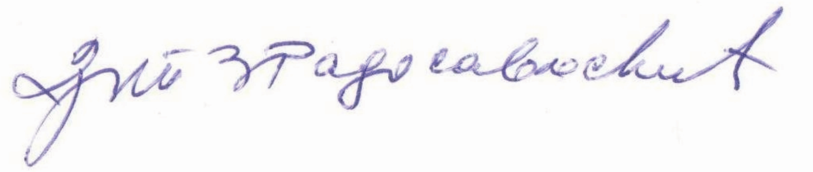 | 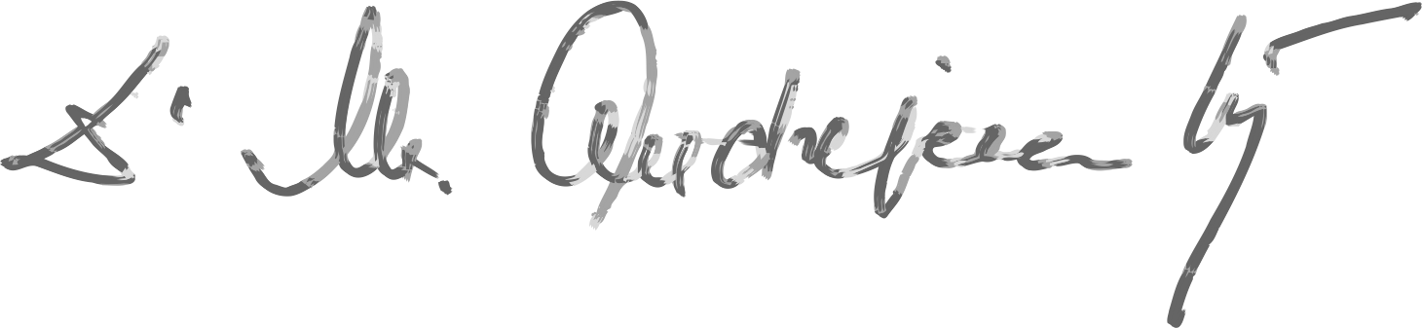
Prim. Tatjana Radosavljević, Ph. MD Mirjana Andrejević-Kry,MD
Manager of Serbian Medical Chamber Chairman of Serbian Society
of Physicians and Dentists
in Germany - GSAeZ

